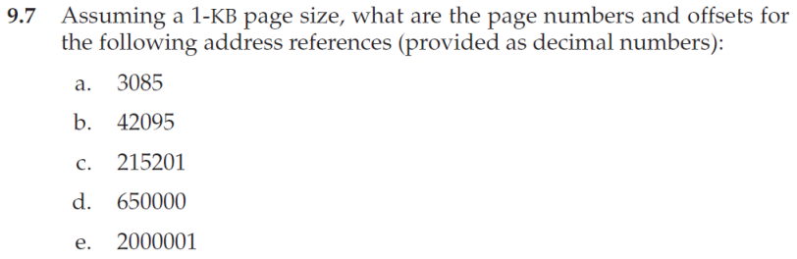

a. page numbers = 3, offsets = 13

b. page numbers = 41, offsets = 111

c. page numbers = 210, offsets = 161

d. page numbers = 634, offsets = 784

e. page numbers = 1953, offsets = 129

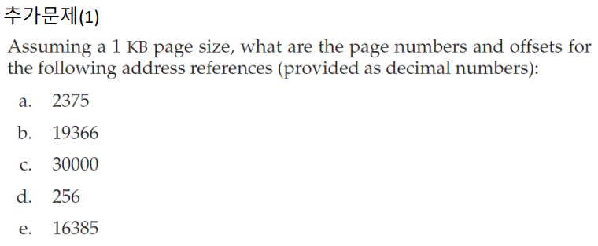

a. page numbers = 2, offsets = 327

b. page numbers = 18, offsets = 934

c. page numbers = 29, offsets = 304

d. page numbers = 0, offsets = 256

e. page numbers = 16, offsets = 1

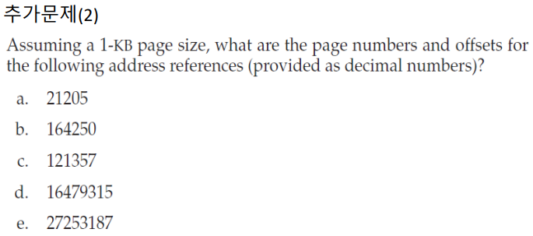

a. page numbers = 20, offsets = 725

b. page numbers = 160, offsets = 410

c. page numbers = 118, offsets = 525

d. page numbers = 16093, offsets = 83

e. page numbers = 26614, offsets = 451